**INTERPRETATION OF FT – IR SPECTRUM**

**Aim**

To interpret the given FT-IR spectrum and Report the possible functional groups

**IR Interpretation**

The interpretation of infrared spectra involves the correlation of absorption bands in the spectrum of an unknown compound with the known absorption frequencies for types of bonds. This table will help users become more familiar with the process. Significant for the identification of the source of an absorption band are **intensity** (weak, medium or strong), **shape** (broad or sharp), and **position** (cm-1) in the spectrum. Characteristic examples are provided in the table below to assist the user in becoming familiar with the intensity and shape absorption bands for representative absorptions.

|  |  |  |
| --- | --- | --- |
| **CHARACTERISTIC INFRARED ABSORPTION FREQUENCIES** | | |
| **Bond** | **Compound Type** | **Frequency range, cm-1** |
| C-H | [Alkanes](http://wwwchem.csustan.edu/tutorials/images/1octano2.gif) | 2960-2850(s) stretch |
| 1470-1350(v) scissoring and bending |
| [CH3 Umbrella Deformation](http://wwwchem.csustan.edu/tutorials/images/cinald.gif) | 1380(m-w) - Doublet - isopropyl, *t-*butyl |
| C-H | [Alkenes](http://wwwchem.csustan.edu/tutorials/images/cinald.gif) | 3080-3020(m) stretch |
| 1000-675(s) bend |
| C-H | [Aromatic Rings](http://wwwchem.csustan.edu/tutorials/images/nitbenz.gif) | 3100-3000(m) stretch |
| [Phenyl Ring Substitution Bands](http://wwwchem.csustan.edu/tutorials/images/irunk04.gif) | 870-675(s) bend |
| [Phenyl Ring Substitution Overtones](http://wwwchem.csustan.edu/tutorials/images/nitbenz.gif) | 2000-1600(w) - fingerprint region |
| C-H | [Alkynes](http://wwwchem.csustan.edu/tutorials/images/ethynl.gif) | 3333-3267(s) stretch |
| 700-610(b) bend |
| C=C | [Alkenes](http://wwwchem.csustan.edu/tutorials/images/cinald.gif) | 1680-1640(m,w)) stretch |
| C****C | [Alkynes](http://wwwchem.csustan.edu/tutorials/images/ethynl.gif) | 2260-2100(w,sh) stretch |
| C=C | [Aromatic Rings](http://wwwchem.csustan.edu/tutorials/images/nitbenz.gif) | 1600, 1500(w) stretch |
| C-O | [Alcohols](http://wwwchem.csustan.edu/tutorials/images/1octano2.gif), [Ethers](http://wwwchem.csustan.edu/tutorials/images/phenet.gif), [Carboxylic acids](http://wwwchem.csustan.edu/tutorials/images/bbutanac.gif), [Esters](http://wwwchem.csustan.edu/tutorials/images/etethat.gif) | 1260-1000(s) stretch |
| C=O | [Aldehyde](http://wwwchem.csustan.edu/tutorials/images/cinald.gif)[s](http://wwwchem.csustan.edu/tutorials/images/acetophn.gif), [Ketones](http://wwwchem.csustan.edu/tutorials/images/acetophn.gif), [Carboxylic acids](http://wwwchem.csustan.edu/tutorials/images/bbutanac.gif), [Esters](http://wwwchem.csustan.edu/tutorials/images/etethat.gif) | 1760-1670(s) stretch |
| O-H | Monomeric -- Alcohols, Phenols | 3640-3160(s,br) stretch |
| Hydrogen-bonded -- [Alcohols](http://wwwchem.csustan.edu/tutorials/images/1octano2.gif), [Phenols](http://wwwchem.csustan.edu/tutorials/images/ocresol.gif) | 3600-3200(b) stretch |
| [Carboxylic acids](http://wwwchem.csustan.edu/tutorials/images/bbutanac.gif) | 3000-2500(b) stretch |
| N-H | [Amines](http://wwwchem.csustan.edu/tutorials/images/toluid1.gif) | 3500-3300(m) stretch |
| 1650-1580 (m) bend |
| C-N | [Amines](http://wwwchem.csustan.edu/tutorials/images/toluid1.gif) | 1340-1020(m) stretch |
| CN | [Nitriles](http://wwwchem.csustan.edu/tutorials/images/benzonit.gif) | 2260-2220(v) stretch |
| NO2 | [Nitro Compounds](http://wwwchem.csustan.edu/tutorials/images/nitbenz.gif) | 1660-1500(s) asymmetrical stretch |
| 1390-1260(s) symmetrical stretch |

v - variable, m - medium, s - strong, br - broad, w - weak

Example Interpretation of Infrared Spectra

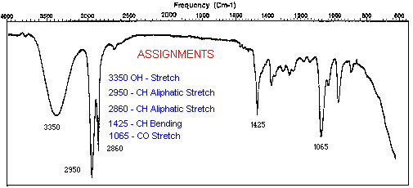

**Perform interpretation for the following Spectrum**

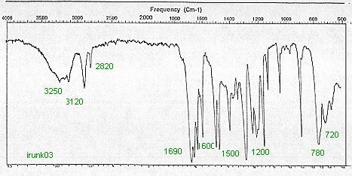

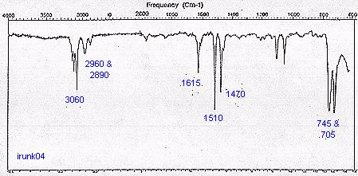

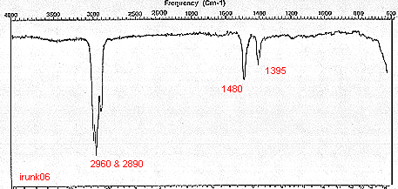

**Report:**